- No njs property groupo logo, the logo is not displayed
- The phone number is incorrect and should be 03333052777
- Remove “zero contractor bias” under request survey quote on front page
- 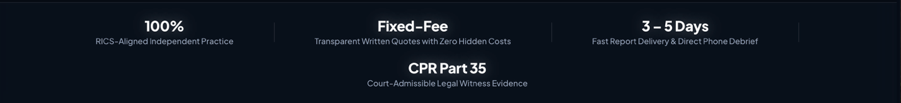
Can out change this above banner to a dark emerald green background so it breaks the page up? Can you bring this down and put the surveying services above this and this at the bottom?

So the change should look like this 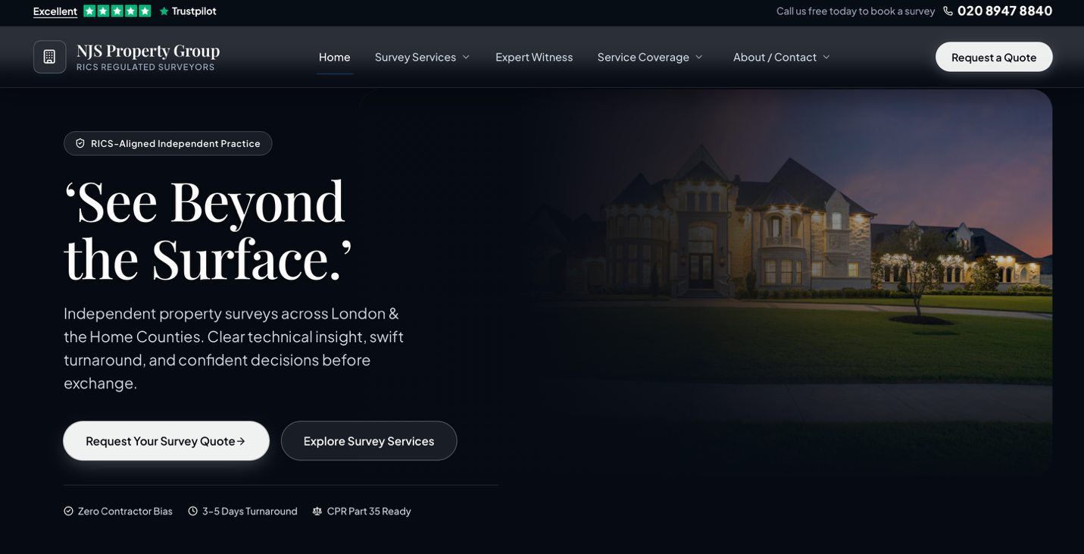

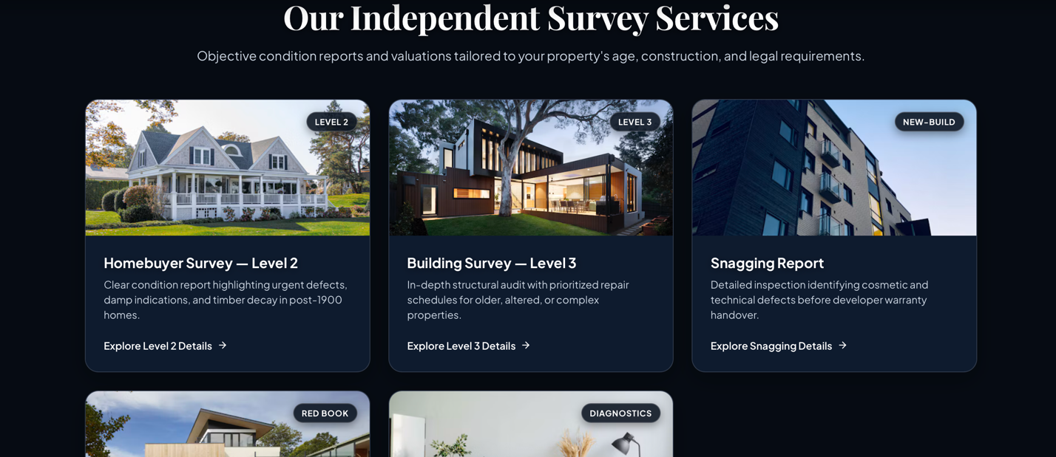

6.
PLEASE MAKE SURE FOR SERVICE COVERAGE THE FOLLOWING AREAS ARE ADDED:

LONDON – EALING, HILLINGDON, BARNET, ILFORD

BUCKINGHAMSHIRE – IVER

BERKSHIRE – LANGLEY,

7. CAN THE FOLLOWING BE ADDED AS FOOTERS NOT IN THE MAIN PAGES – CHP, PRIVACY NOTICE AND DATA PROTECTION, ALSO NOTE ON SERVICE COVERAGFE PAGE THERE ARE 2 OR 3 CHP NOTICES, PLEASE REMOVE

8. FREQUENTLY ASKED QUESTIONS PLEASE CHANGE ANSWER TO THE BELOW - How quickly can a survey be booked and carried out?
Once terms are agreed, on-site physical inspections are typically scheduled within 1 to 3 working days, subject to property access granted by the estate agent or vendor. Urgent timescales can be accommodated upon request

8. please add RICS regulated logo, CIOB, EWI and MRPSA logo as below

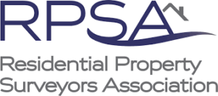
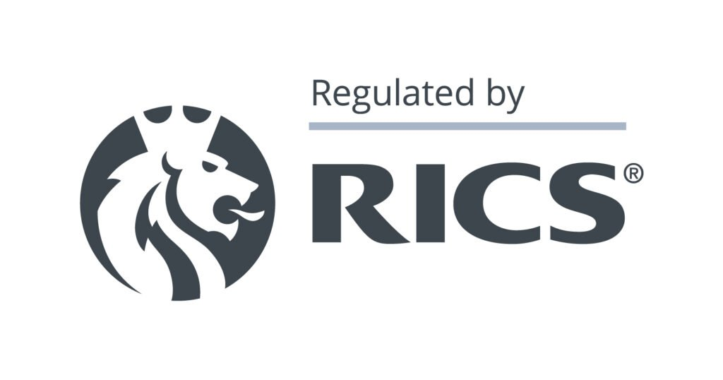
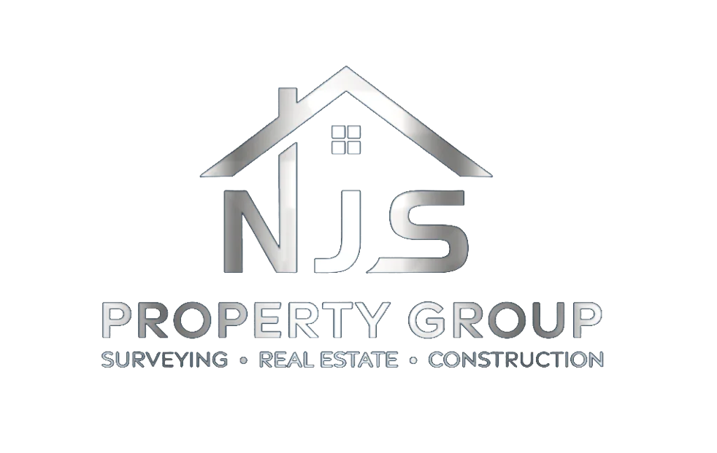

PLEASE USE OUR ADDRESS ALSO..

